Full Name | Chekka Nagaraju
Batch | MS FSD DEC 2021 Cohort 1
Project Name | Geography Quiz
Project Submission Date | 05-07-2022

Source Code
Welcome Page
<nav class="navbar navbar-dark bg-primary">
<div class="container">
<a class="navbar-brand" href="#">
<span>Geography Quiz</span>
</a>
</div>
</nav>
<!-- https://www.drodd.com/images15/letter-m47.png -->

Questions
<div class="container mt-4">
<div class="card">
<ng-container *ngIf="!isQuizCompleted">
<div class="d-flex justify-content-between p-3">
<div class="image">
<img src="assets/Images/geography.jpg" alt="Logo" width="200" heiight="175" >
</div>
<div class="header">
<h4 style="font-style: italic;"> Geography Quiz </h4>
<span style="font-style: italic;">Welcome {{name}}</span>
</div>
</div>
<div class="d-flex justify-content-around p-3">
<div class="score">
<h5>{{points}} points</h5>
</div>
<div class="QuestionsRemain">
<span>
Question {{currentQuestion+1}} of {{questionList.length}} <!--Its starts from 0 . so +1. -->
</span>

</div>
<div class="Timer">
<h5>{{counter}} sec</h5>

</div>
</div>
<div class="progress mb-4">
<div class="progress-bar bg-success" role="progressbar" [ngStyle]="{'width':progress+'%'}" aria-valuenow="25" aria-valuemin="0" aria-valuemax="100"></div>
</div>
<div class="question">
<div class="card">
<h3>{{questionList[currentQuestion]?.questionText}}</h3>
</div>
</div>
<div class="options">
<ol *ngFor="let option of questionList[currentQuestion]?.options">
<li (click)="answer(currentQuestion+1,option)">
<div appChangeBg [isCorrect]="option.correct" class="card">
{{option.text}}
</div>
</li>

</ol>

</div>
<div class="d-flex justify-content-between">
<button [disabled]="currentQuestion==0" class="btn" (click)="previousQuestion()"> <i class="fa text-primary fa-chevron-left fa-3x" aria-hidden="true"></i> </button>
<button class="btn" (click)="resetQuiz()"> <i class="fa text-primary fa-refresh fa-3x" aria-hidden="true" aria-hidden="true"></i> </button>
<button [disabled]="currentQuestion==questionList.length-1" class="btn" (click)="nextQuestion()"> <i class="fa text-primary fa-chevron-right fa-3x" aria-hidden="true"></i> </button>
</div>
</ng-container>

<ng-container *ngIf="isQuizCompleted">
<div class="row d-flexjustify-content-between">
<img style="width:300px;" class="img-fluid col-sm-12 mx-auto" src="assets/Images/Celebration.jpg" alt="Celebration Logo" width="35" heiight="25" >
<div class="result text-center col-md-6 col-sm-12">
<h3>Congratulations!! <br> {{name}} <br> You have completed the Sports Quiz. <br> Below is your result:</h3>
<p>Total Question Attempted : {{questionList.length}}</p>
<p>Total Correct Answered : {{correctAnswer}} </p>
<p>Total Wrong Answered : {{incorrectAnswer}} </p>
<p>Your Score : {{points}} Points</p>
</div>
</div>
</ng-container>
</div>
</div>>

First Page
<div class="container bg-light py-5">
<h1 class="display-5 fw-bold">Welcome to MyQuiz App</h1>
<p class="col-md-8 fs-4"> This Quiz contains 10 questions. Each holds 10 Points. </p>
<h4>Rules:</h4>
<ol>
<li>Correct Question gives 10 points.</li>
<li>Incorrect Question gives -10 points.</li>
<li>You will get 50 seconds to answer each Question.</li>
<li>Refreshing the page will reset the Quiz.</li>
</ol>
<h1 style="font-family: Cursive; text-align:center">All The Best</h1>

<div class="name col-md-4 my-3">
<label for="">Enter Your Name:</label>
<input #name type="text" class="form-control">
</div>
<button class="btn btn-primary btn-lg" routerLink="/question" (click)="startQuiz()" >Start The Quiz</button>

</div>

Questions.json
{
"questions": [{
"questionText": " What is the largest Desert in the world?",
"options": [{
"text": "Antarctica",
"correct": true
},
{
"text": "Sahara"
},
{
"text": "Atacama"
},
{
"text": "Gobi"
}
],
"explanation": "Antarctica is the largest ice desert in the world. Sahara is the largest Sand desert in the world. "
},
{
"questionText": "The India’s higest annual rainfall is reported at ??",
"options": [{
"text": "Kakinada"
},
{
"text": "Delhi"
},
{
"text": "Munnar"
},
{
"text": "Mawsynram, Meghalaya",
"correct": true
}
],
"explanation": " "
},
{
"questionText": "The Radcliffe line is boundary between?",
"options": [{
"text": "India and Nepal"
},
{
"text": "India and Pakistan",
"correct": true
},
{
"text": "Pakistan and Afghanistan"
},
{
"text": "Bangldesh and Myanmar"
}
],
"explanation": " "
},
{
"questionText": "The state having largest area of forest cover in India is ?",
"options": [{
"text": "Andhra Pradesh"
},
{
"text": "Madhya Pradesh",
"correct": true
},
{
"text": "Uttar Pradesh"
},
{
"text": "Arunachal Pradesh"
}
],
"explanation": " "
},
{
"questionText": "Which state in India has the largest number of district?",
"options": [{
"text": "Andhra Pradesh"
},
{
"text": "Uttar Pradesh",
"correct": true
},
{
"text": "Madhya Pradesh"
},
{
"text": "Arunachal Pradesh"
}
],
"explanation": " "
},
{
"questionText": "which atomic power station in India is built completely indigenously?",
"options": [{
"text": "Ramagundam"
},
{
"text": "Kakrapar"
},
{
"text": "Tarapur"
},
{
"text": "Kalapakkam",
"correct": true
}
],
"explanation": " "
},
{
"questionText": "The permeable rock layer which retains water?",
"options": [{
"text": "Lagoon"
},
{
"text": "Aquifer",
"correct": true
},
{
"text": "Hot Spring"
},
{
"text": "Estaury"
}
],
"explanation": " "
},
{
"questionText": "Name given to the widened river mouth found at the point a river enters the sea?",
"options": [{
"text": "Lagoon"
},
{
"text": "Estaury",
"correct": true
},
{
"text": "Hot Spring"
},
{
"text": "Aquifer"
}
],
"explanation": " "
},
{
"questionText": "Which ocean surrounds the North Pole?",
"options": [{
"text": "Arctic Ocean",
"correct": true
},
{
"text": "Atlantic Ocean"
},
{
"text": "Pacific Ocean"
},
{
"text": "Indian Ocean"
}
],
"explanation": " "
}
]
}

Screen Shots
Login Page
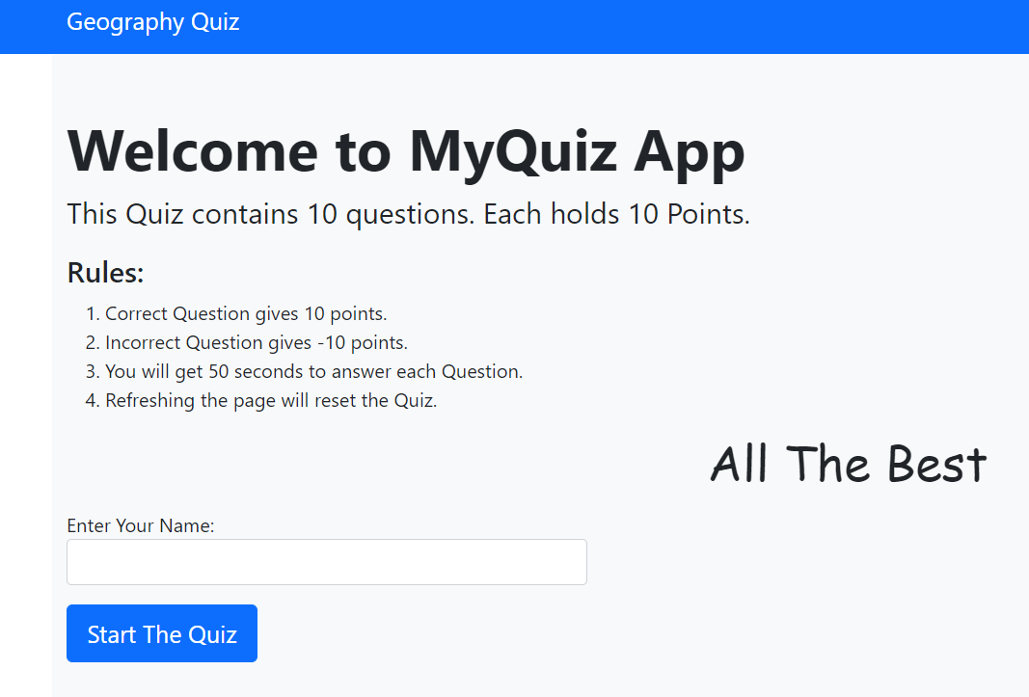

Enter the Name:
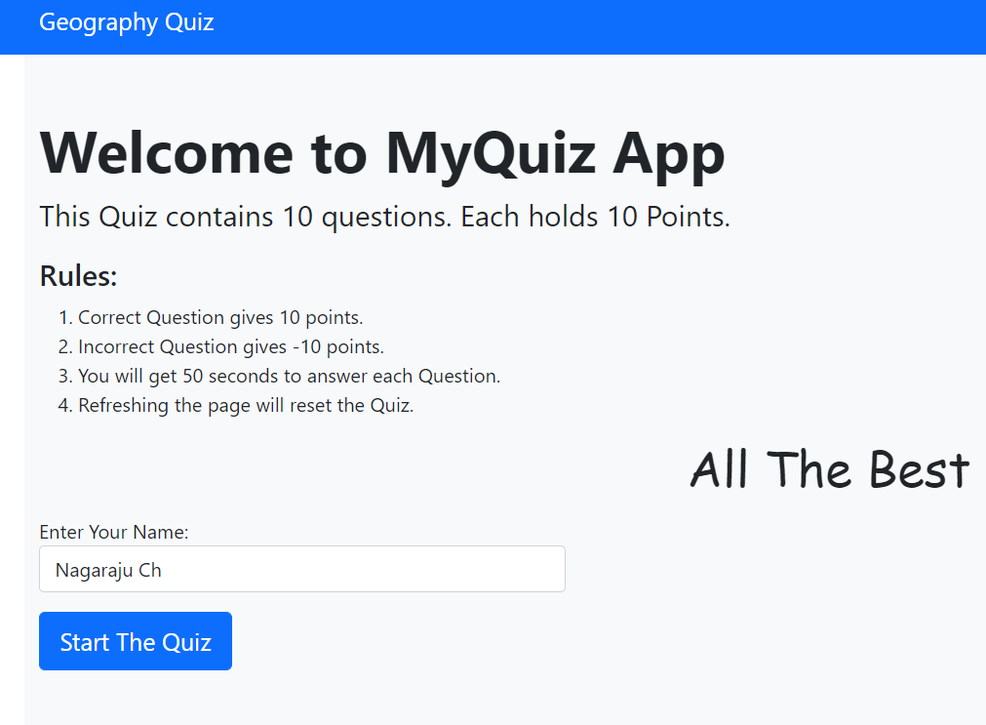
Questions
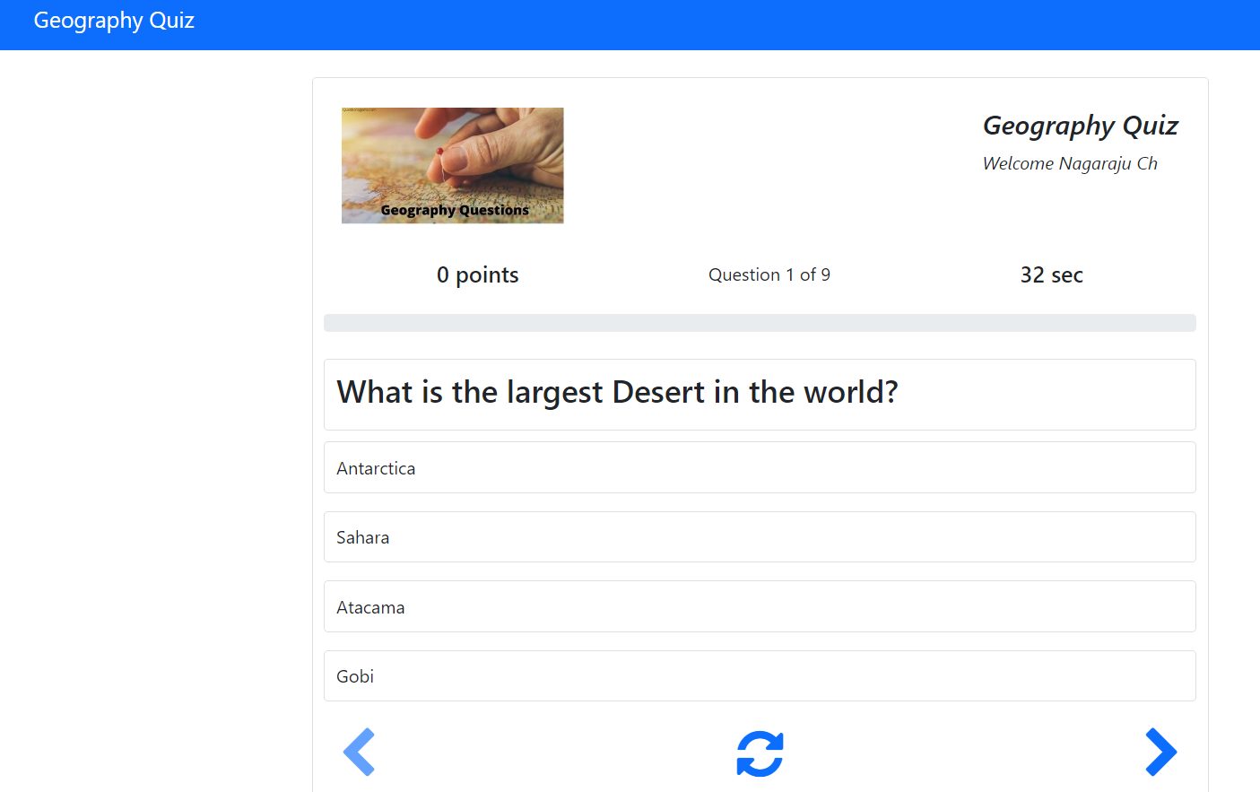

Question with points
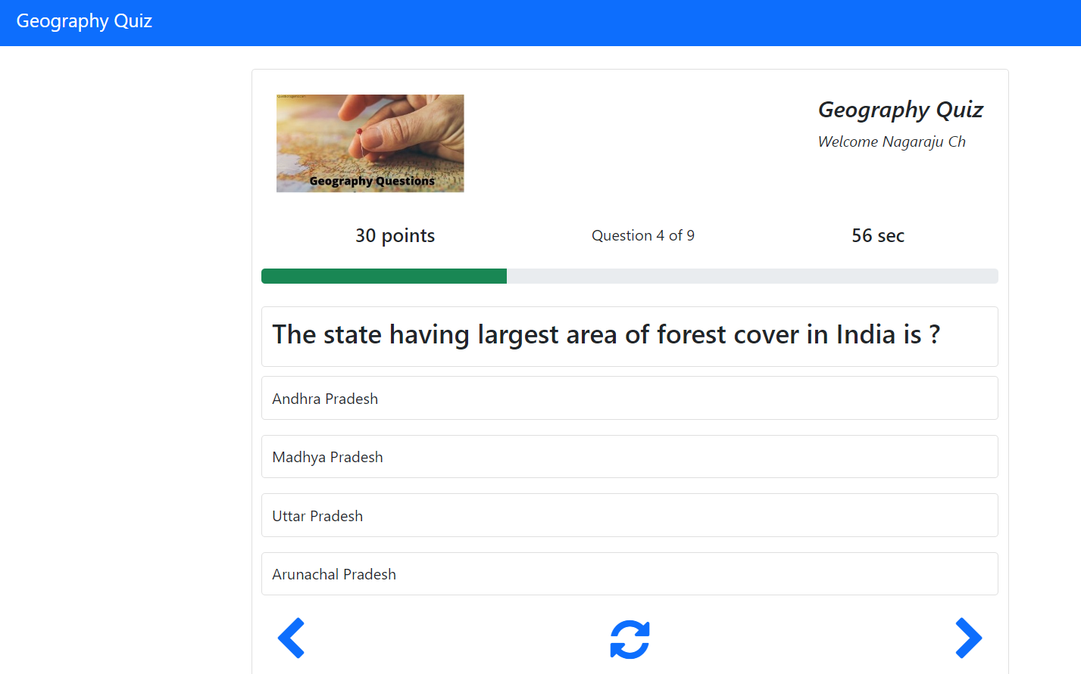

Final Result
